# Module 1 Activity 2: Project Setup

# Brandon Trinkle

# IFT 458: Middleware Prog & Database Sec

# Professor: Dinesh Sthapit

# Jan 17, 2025

# Module 1 Activity 2: Project Setup

Task 1: Screenshot of the terminal showing the successful execution of npm init -y.

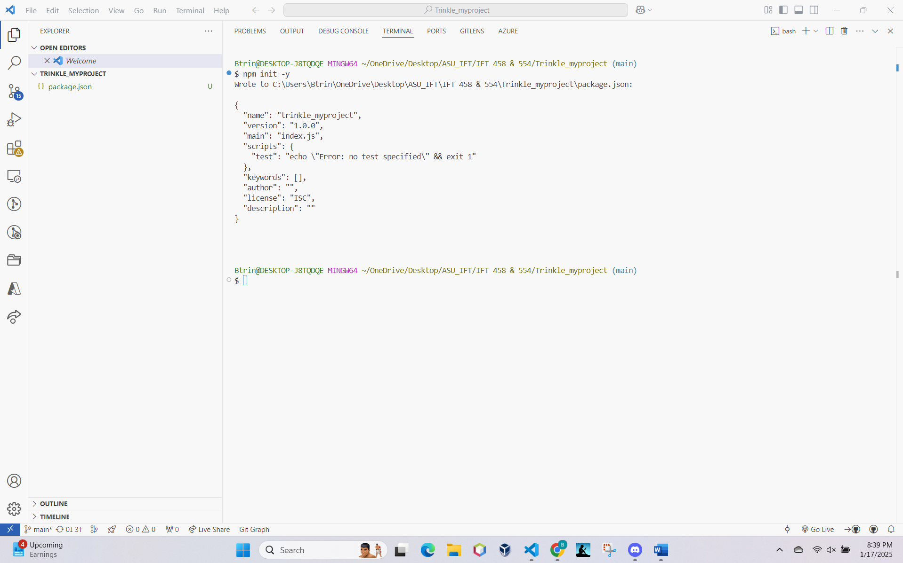

Task 2: Screenshot of Visual Studio Code showing the index.js file in the Explorer.

Task 3: Screenshot of the index.js file opened in the editor.

Task 4a: Screenshot of the terminal showing the installation of Express.js.

Task 4b: Execution of command npm -v

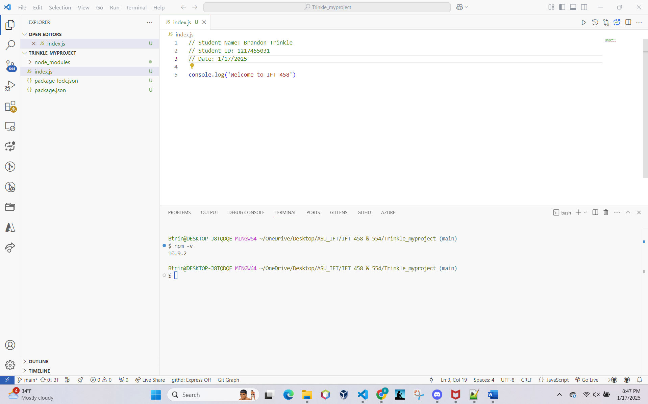

Task 5: Screenshot of the index.js file with the code.

Task 6: Screenshot showing AutoSave enabled.

Task 7: Screenshot of the terminal executing node index.js and displaying output.

